“Київський фаховий коледж зв’язку”

Циклова комісія комп’ютерної та програмної інженерії

**ЗВІТ ПО ВИКОНАННЮ**

**ЛАБОРАТОРНОЇ РОБОТИ №7**  
з дисципліни: «Операційні системи»  
Тема: “Створення скриптових сценаріїв та визначення апаратної конфігурації системи”

Виконали студенти

групи БІКС-13

Команда JRSY: Андрущик П.С   
Бурбан Д.Ю.  
Перевірив викладач

Сушанова В.С.

Київ 2024

**The goal of the work: (робила студентка Андрущик Поліна)**Getting hands-on skills with the Bash shell.Getting to know basic actions when working with script scenarios.  
  
1. *Read the short theoretical information for the laboratory work and make a small dictionary of basic English terms for the assignment of commands and their parameters.

|  |  |
| --- | --- |
| **Term in English** | **Term in Ukrainian** |
| Shell Script | Файл, що містить виконувані команди, збережені в текстовому форматі. Під час виконання кожна команда у файлі виконується послідовно. |
| Script Execution | Сценарії оболонки можна виконувати, передаючи їх як аргументи оболонці або запускаючи безпосередньо. Щоб дозволити виконання, потрібно встановити дозволи. |
| Scripting Basics | На додаток до виконання команд, сценарії оболонки включають розуміння змінних, умов і циклів. |
| Conditionals | Конструкції, які дозволяють сценарію виконувати різні дії на основі заданих умов. |
| Variables | Місця тимчасового зберігання, які використовуються для зберігання даних у сценарії. |

**Based on the missing material, answer the following questions: (робила студентка Андрущик Поліна)  
*Describe the concept of a shell script.**A shell script is a text file containing a sequence of commands to perform certain tasks that can automate routine user actions or perform more complex operations using command line capabilities.  
 **\*How are scripts created and edited, what must be done to run the script?**Scripts are created in text editors such as GNU nano or vi/vim, where commands can be entered directly from the keyboard, after which they can be saved with the extension ".sh", and in order to run them, the appropriate access rights must be set using the command "chmod " and specify the path to the interpreter in the first line of the script (shebang), after which they can be executed by passing them as arguments to the shell or by running them directly.  
  
**\*\*What main components of a motherboard do you know?**The main components of the motherboard are the central processing unit (CPU) - the brain of the computer that performs calculations, memory slots (which can be for random access memory RAM or permanent memory ROM), connectors for connecting expandable memory cards (such as PCI Express for graphics cards or USB for connecting peripherals), and the chipset chip that manages the interfaces between these components.  
  
**\*\*Briefly describe for which devices the concepts of MBR and GPT are used?**The concepts of MBR (Master Boot Record) and GPT (GUID Partition Table) operate to manage partitions on data storage such as hard drives or SSDs. MBR is used on older systems and is limited to 2.2 terabytes per partition, while GPT, a more modern technology, allows for larger partitions, supports more disk sizes, and provides better reliability through data backups. GPT is usually used for newer systems or devices that need support for larger data volumes and high transfer speeds.  
  
**\*\*What is the essence of the mounting operation, why is it needed?**A mount operation is to mount a file system (such as NTFS, EXT4, etc.) that is stored on a storage device (such as a hard disk, SSD, or USB drive) to a specific point in the operating system's file hierarchy. This is necessary to make data stored on this device readable and writable by users and operating system programs. Mounting allows the operating system to identify and access files and directories on the storage device as part of the overall file system, making them available for use.  
 **Progress (робив студент Бурбан Данило)**

**Start your Linux operating system (if you're on your own PC and have it installed) and launch a terminal.**

**Work through all the command examples presented in the labs of the NDG Linux Essentials course - Lab 11: Basic Scripting and Lab 12: Understanding Computer Hardware. Create a table to describe these commands**

| **Command** | **Description** |
| --- | --- |
| test –f /dev/ttyS0 | 0 if the file exists |
| test ! –f /dev/ttyS0 | 0 if the file doesn’t exist |
| test –d /tmp | 0 if the directory exists |
| test –x `which ls` | substitute the location of ls then test if the user can execute |
| test 1 –eq 1 | 0 if numeric comparison succeeds |
| test ! 1 –eq 1 | NOT – 0 if the comparison fails |
| test 1 –ne 1 | Easier, test for numeric inequality |
| test “a” = “a” | 0 if the string comparison succeeds |
| test “a” != “a” | 0 if the strings are different |
| test 1 –eq 1 –o 2 –eq 2 | -o is OR: either can be the same |
| test 1 –eq 1 –a 2 –eq 2 | -a is AND: both must be the same |
| exit | The exit command is used to exit the shell. It terminates the current session and returns control to the parent process. |
| grep | The grep command is used to search text data for patterns specified by the user. It filters lines that match the pattern. |
| Free -m | The free -m command displays information about free and used memory in the system, in megabytes. |
| lspci | The lspci command displays information about all PCI (Peripheral Component Interconnect) devices connected to the system. |
| lsusb | he lsusb command displays information about all USB devices connected to the system. |
| gdisk | he gdisk command is an interactive interface for working with the GPT (GUID Partition Table) disk structure. It allows creating, editing, and deleting partitions on a disk. |
| cgdisk | The cgdisk command is also an interactive interface for working with the GPT disk structure but with a console-based graphical interface. |
| umount | The umount command is used to unmount (detach) mounted file systems. It ensures the safe disconnection of the file system before removing the device or changing the media. |

|  |  |
| --- | --- |
| **Ctrl + W** | **search the document** |
| **Ctrl + W, then Control + R** | **search and replace** |
| **Ctrl + G** | **show all the commands possible** |
| **Ctrl + Y/V** | **page up / down** |
| **Ctrl + C** | **show the current position in the file and the file’s size** |

**Create script scripts that output text messages to the user (show screenshots):**

**the script should output a greeting to the current user indicating the current date and information about the current system;**

**\*the script should output information about the hardware configuration of the current system (use the commands discussed in Lab 12: Understanding Computer Hardware);**

**\*\*give your example script scenario.**

**3.1**

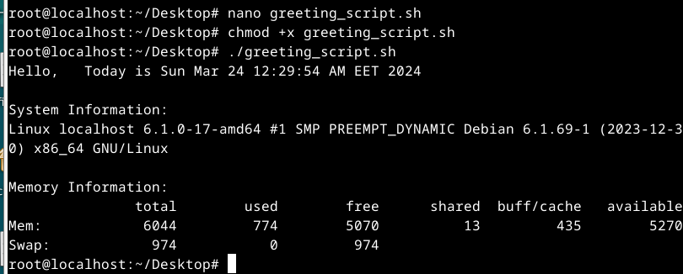

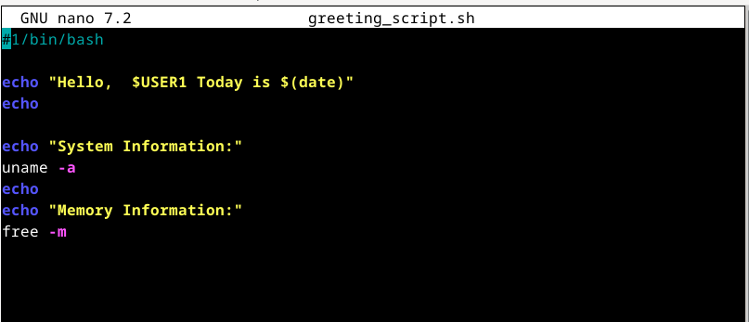

**3.2**

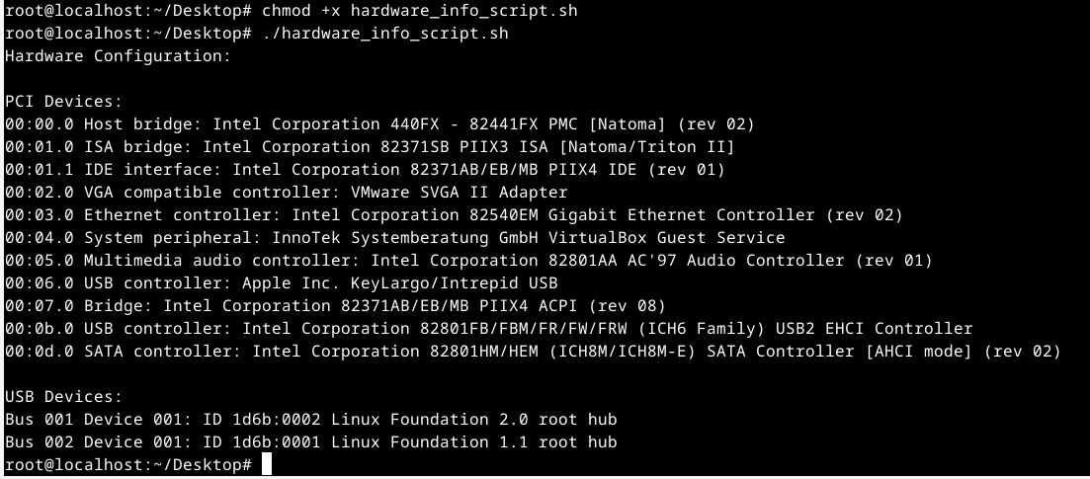

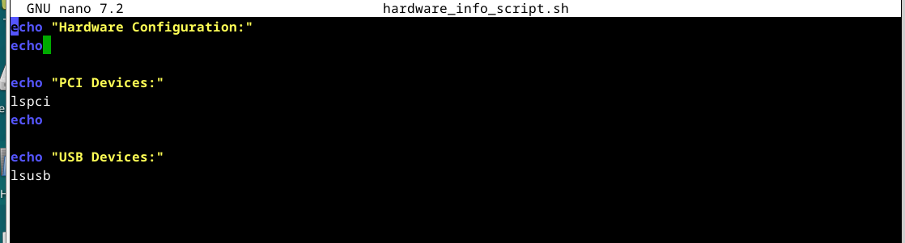

**1.** 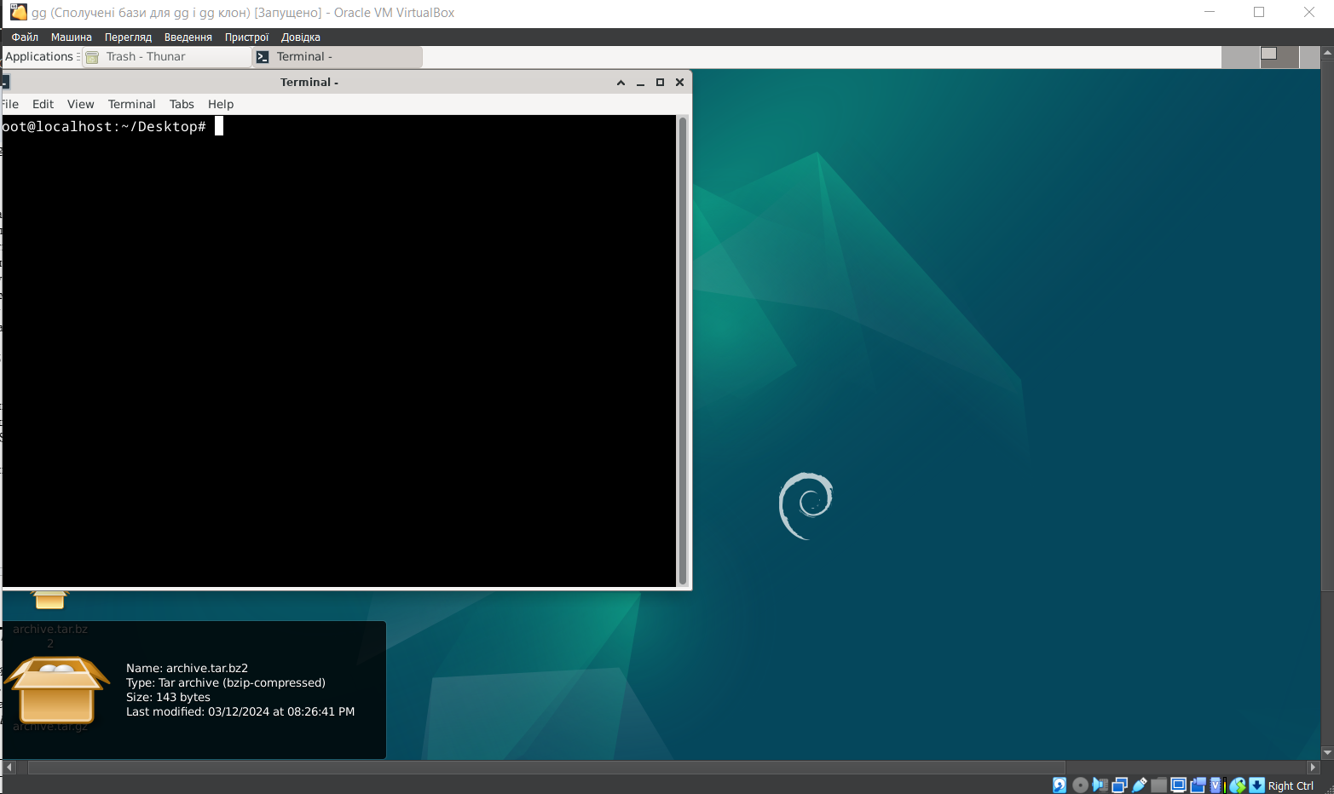

**Answers to control questions (робила студентка Андрущик Поліна)  
What is the difference between arch and lscpu commands?**The arch command displays the system architecture ID, while the lscpu command provides detailed information about the processor, including its architecture, number of cores, model, speed, instructions, etc.

**What command can be used to get information about the state of RAM usage by the current system?**To obtain information about the state of RAM usage by the current system, you can use the "free" command, which displays detailed data on the amount of free and used RAM, as well as the memory used for buffers and caching.

**\*How can scripts handle variables and create branching and looping scenarios?**In scripts, variables are processed by assigning values and using them in commands and expressions. To create branching scripts, conditional execution constructs such as "if-then-else" are used, where the execution of commands depends on specified conditions. Looping scripts are implemented using loops such as "for", "while" or "until" that allow a set of commands to be executed many times until a certain condition is met.

**\*What commands can be used in the terminal to view the connection status of peripheral devices?**In a terminal, you can use lsusb to view connected USB devices and lspci to view peripherals that are connected via the PCI bus on your system.

**\*\*What are the features of the gparted screen saver?**GParted is a program for managing disk partitions in many operating systems. It provides the ability to create, delete, resize, move, rename and format hard disk partitions. In addition, it supports various file systems such as NTFS, FAT32, ext4, etc. GParted also allows you to perform disk operations such as verifying and restoring partitions, changing the partition type, and copying and restoring partitions.  
  
**Сonclusion (робив студент Бурбан Данило)  
So, you can use the Nano text editor to create scripts. After creating the script and saving it to an executable file, you need to give it execute rights using the chmod +x script_name.sh command. You can then run this script using the ./script_name.sh command in the terminal. They also answered questions, made a table, consolidated knowledge**